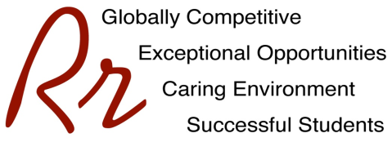

# **Rocky River City Schools**

#### Kensington Intermediate School

# **Grade 5 Supply List – All Teams**

# **2022 - 2023**

The following yearly fee is charged for all students. This fee is for materials and supplies, which will be used during the year. Fees may be paid by CASH or CHECK, made payable to Kensington Intermediate School. To avoid confusion EACH child should have his/her own check or cash for fees. Fees may also be paid along with milk/juice accounts via EZpay found here: <https://www.spsezpay.com/RockyRiver/login.aspx>

**MATERIALS FEE $55.00**

**In addition, the following items need to be purchased outside of school:**

* 3 Three-Ring Binders (1”Binders) One Each: Black, White, and Red
* 1 Three-Ring Binder (1.5” Binder - Blue)
* 1 Package of Binder Divider Tabs (8 Tabs Per Package)
* 1 One Subject Spiral Notebook
* 2 Pocket Folders
* 2 Packages of Loose Leaf Paper
* 2 Boxes of Tissues
* Large, Zippered Pencil Case for Pencils, Markers, etc. (No Art Boxes)
* Colored Pencils
* Crayons (24 Size Recommended)
* Art Shirt
* 4 Black Sharpie Fine Point Markers (Two are for Art)
* 2 Classic Marker Sets (One Set is for Art. Please Get Thick Ones for Art.)
* 2 Scissors (One is for Art)
* 1 Liquid Glue (Art Class)
* 2 Glue Sticks (Large)
* 4 Expo Dry Erase Markers (Low Odor Variety Preferred) No Neon Colors
* 2 Highlighters
* #2 Pencils - 1 Pack (Sharpened)
* 1 Pack of Red Pens
* Post It Notes (3” X 3” Size)
* 2 Earbuds or Headphones - Must Stay at School
* Tennis Shoes for Fitness/Health
* Disinfecting Wipes
* Hand Sanitizer - Personal Size

**\*Students may need additional binders/or additional spiral notebooks\***

(Teachers will provide specific details during the first week.)

Please do not bring trapper keepers as they do not fit in student desks. Backpacks must fit into a locker. Please no rolling backpacks.

**\*\*\*\*\*\*\*\*\* PLEASE PLACE STUDENT NAMES ON ALL ITEMS \*\*\*\*\*\*\*\*\***

**PLEASE REPLENISH SUPPLIES AS NEEDED.**